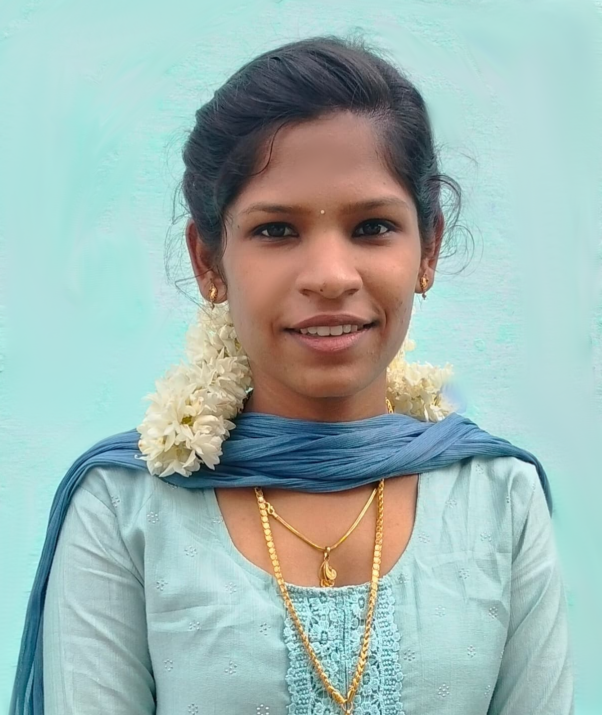

**Durai Mathy R**

**E-mail:** rajmathy14@gmail.com

* Tamil
* English

**Languages**

**Professional Developments**

**Paper Presentation:**

1. Infant Jesus college of engineering, Tuticorin (Patient monitoring system using ZigBee)
2. Scad college of engineering, Cheran mahadevi, Tirunelveli (IoT in agriculture)

**Certificates:**

1. Red Hat System Administration – Red Hat Academy
2. Introduction to IoT and Digital Transformation – Cisco Networking Academy
3. Introduction to Cybersecurity - Cisco Networking Academy
4. Networking Essentials - Cisco Networking Academy
5. AI agents for beginners – Simplilearn

**Mini Projects:**

1. IoT colour based product sorting machine project
2. Smart home energy management: automation switch contron using IoT

**Interests**

* Mehandi Art
* Cooking

**Skills**

**Programming Skills:**

* Python
* C program
* C++

**Technical Skills:**

* Matlab
* Keil µVision 4 & 5
* Anaconda Navigator
* Dev C++

***Power Integrated Solutions, Trichy – (June 30 to July 30) 2025***

* Completed training in Embedded Systems and IoT
* Gained hands-on experience in Arduino programming and coding
* Worked with both hardware and software simulations

**Internship**

**Education**

* Thamirabharani Engineering College (Autonomous), Tirunelveli.
* B.E. Electronics and Communication Engineering, - (2022 - Present) - 8.01% CGPA (as of Semester 6)
* Sarah tucker higher secondary school, palayamkottai.
* HSC / Higher Secondary Education 2022 - 66.17%
* SSLC / General Education 2020 - 69.8%

I'm someone who enjoys working with people and bringing positive energy into whatever I do. I’m open-minded, easy to talk to, and love learning new. Whether it’s leading a group or just having fun while getting things done.

**Objective**

**Address:** 66/483(A), New colony, V.M. Chatram, Maharaja nagar (post), Palayamkottai, Tirunelveli - 627011

**LinkedIn:** linkedin.com/in/durai-mathy-2abb7629b